Title (Times New Roman font, size 14)
First Author¹, Second Author², Third Author³ (Times New Roman font, size 12, bold). The name of the presenting author should be underlined.

¹ Affiliation, Address 1, City, Country, contact-author E-mail (Times New Roman font, size 10)
² Affiliation, Address 1, City, Country (Times New Roman font, size 10)
³ Affiliation, Address 1, City, Country (Times New Roman font, size 10)

Introduction (Times New Roman font, size 12, bold). Authors have to use this template to prepare their abstract to be submitted to BiomMedD 2026 (Times New Roman font, size 12). Citations should be given with numbers in brackets [1] and listed at the end of the abstract.

Experimental. The total abstract length should be 1 page maximum, no more than 300 words. Any abstract exceeding 1 page will not be considered.

Results and Discussion. The text of the abstract should be written using the Times New Roman font, size 12. Subtitles should be in bold.
1 Illustration maximum (Figure or Table).

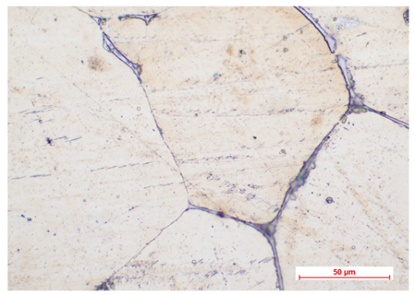
Fig. 1: Legend (Times New Roman font, size 11, italics)

Conclusions. Save your abstract as a Word file before submission. The submission must be done by email at contact@biommedd.ro.

References. (Times New Roman font, size 11)
[1] Author 1, A.B.; Author 2, C.D. Title of the article. Abbreviated Journal Name Year, Volume, page range
[2] Author 1, A.; Author 2, B. Book Title, 3rd ed.; Publisher: Publisher Location, Country, Year; pp. 154–196.

